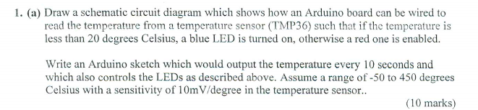

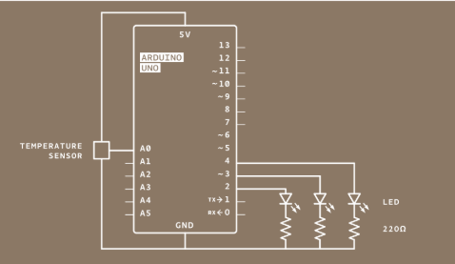

const int sensorpin = A0;

void setup()

{

serial.begin(9600);

pinmode(2, output);

digitalwrite(LOW);

pinmode(3, output);

digitalwrite(LOW);

}

void loop()

{

sensorTem = analogRead(sensorpin);

float voltage = (sensorTem / 1023) * 5;

float tem = (voltage - .5) * 100;

if(tem < 20)

{

digitalwrite(2, High);

digitalwrite(3, Low);

}

else

{

digitalwrite(2, Low);

digitalwrite(3, High);

}

delay(10000);

}

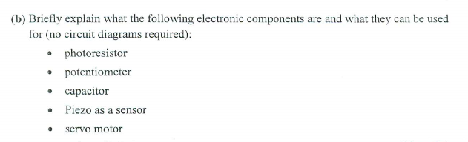

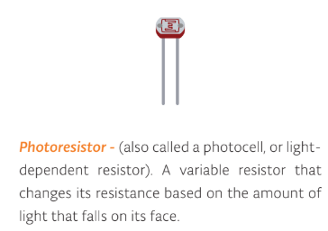

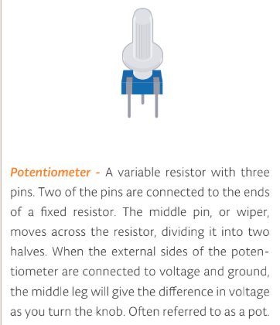

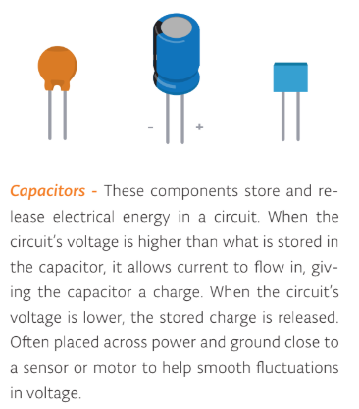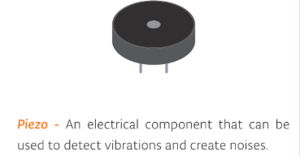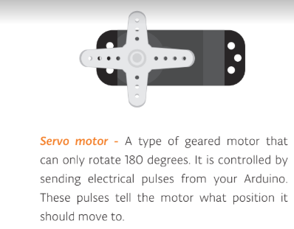

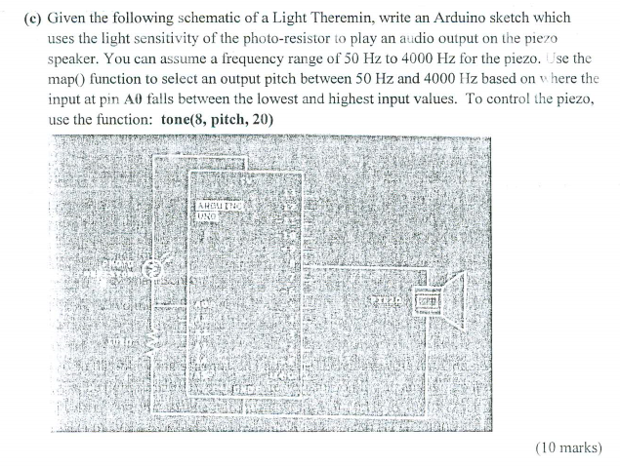

// variable to hold sensor value

int sensorValue;

// variable to calibrate low value

int sensorLow = 1023;

// variable to calibrate high value

int sensorHigh = 0;

void setup() {

pinMode(ledPin, OUTPUT);

digitalWrite(ledPin, HIGH);

// calibrate for the first five seconds after program runs

while (millis() < 5000) {

// record the maximum sensor value

sensorValue = analogRead(A0);

if (sensorValue > sensorHigh) {

sensorHigh = sensorValue;

}

// record the minimum sensor value

if (sensorValue < sensorLow) {

sensorLow = sensorValue;

}

}

}

void loop() {

//read the input from A0 and store it in a variable

sensorValue = analogRead(A0);

// map the sensor values to a wide range of pitches

int pitch = map(sensorValue, sensorLow, sensorHigh, 50, 4000);

// play the tone for 20 ms on pin 8

tone(8, pitch, 20);

// wait for a moment

delay(10);

}

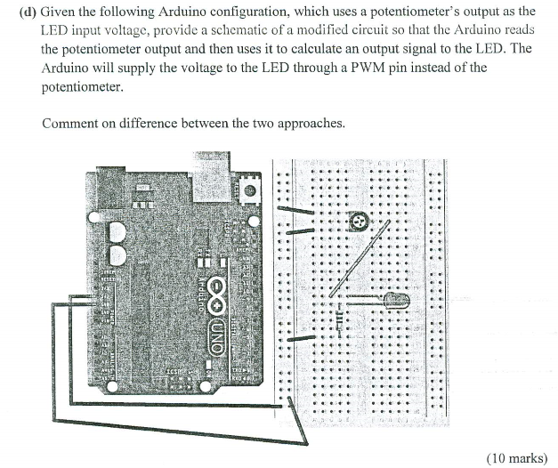

????

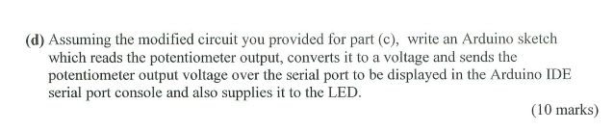

???? 2016的唯一一个不一样

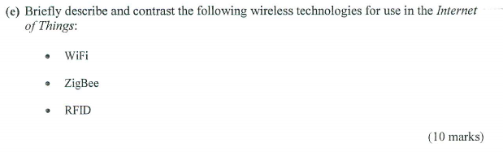

<https://zhidao.baidu.com/question/146287178>

Radio Frequency Identification (RFID) technology, also known as Radio Frequency Identification (RFID), is a communication technology that USES Radio signals to identify specific targets and read and write related data, without the need to establish mechanical or optical contact between the Identification system and specific targets.

Rf, generally microwave, 1-100ghz, suitable for short distance identification communication.

ZigBee is a low power LAN protocol based on IEEE802.15.4 standard. According to international standards, ZigBee technology is a short-range, low-power wireless communication technology.

It is characterized by short range, low complexity, self - organization, low power consumption and low data rate. Mainly suitable for automatic control and remote control field

**WiFi** is a technology that uses radio waves to provide network connectivity.

very high speed.

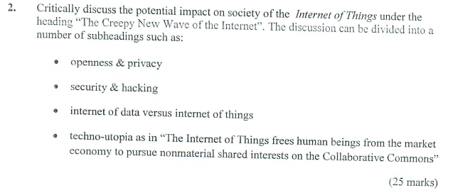

????

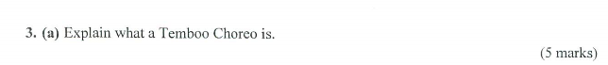

**Temboo** is a scalable, fault-tolerant environment for running and managing smart code snippets that we call Choreos. Choreos can call APIs, simplify the OAuth process, send email messages, perform encoding, update databases, and lots more.

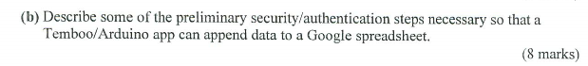

* You'll need a Google account. If you don't already have one, you can sign up [here](https://accounts.google.com/NewAccount).
* Login to [Google's Developer Console](https://console.developers.google.com/), and create a new **Project** if you haven't done so already.
* Using the [API Manager](https://console.developers.google.com/apis/library), make sure you've enabled API Access for the API you want to use in the **Overview** tab.
* Under the **Credentials** tab, create a new **Client ID** and specify **Web application** for the Application Type.
* When configuring the **Consent Screen**, make sure you fill out the **Email Address** and **Product Name** fields.
* Save the Consent screen details. Specify this callback URL as the **Authorized Redirect URI**:

https://{Your Temboo Account Name}.temboolive.com/callback/google

SELECT ALL

* Run the [Google > OAuth > InitializeOAuth](https://www.temboo.com/library/Library/Google/OAuth/InitializeOAuth/) Choreo, specifying the Client ID from the app you registered at Google and the appropriate Scope.
* Open a new web browser, navigate to the authorization URL returned by the InitializeOAuth Choreo, and click "Accept" to grant the app access to your Google account.
* Run the [Google > OAuth > FinalizeOAuth](https://www.temboo.com/library/Library/Google/OAuth/FinalizeOAuth/) Choreo, specifying the callback ID returned earlier by the InitializeOAuth Choreo. This process will return a Refresh Token which can be used along with the Client ID and Client Secret to authenticate with Google.

1. login to google’s developer console to create new project
2. use API manager to enable google spreadsheet api access
3. create new client id and specify web application
4. run initializeOauth choreo with client id and spreadsheet scope
5. run finalizeOauth choreo with client id, client secret and call back id.
6. download source code

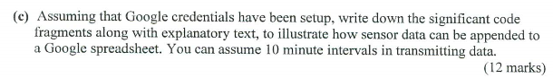

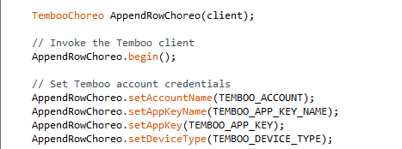

Invoke the temboo client and set temboo account credentials.

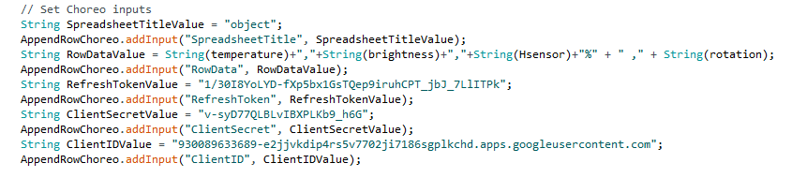

change values of temperature, brightness, humidity and potentiometer to string and insert data in to spreadsheet which name is “object” in google drive.

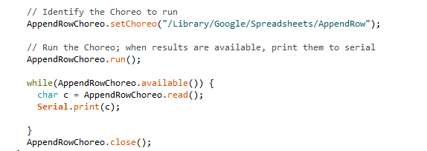



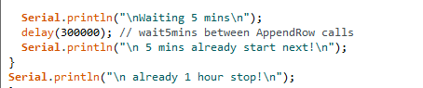

Use for loop to insert data 12 times, each interval time is 5 mins, so total is 1 hour.



Transistor - A three legged device that can operate as an electronic switch. Useful for controlling high current/high voltage components like

motors. One pin connects to ground, another

to the component being controlled, and the

third connects to the Arduino. When the com-

ponent receives voltage on the pin connected

to an Arduino, it closes the circuit between the

ground and the other component.

